**Pershing’s Parade**

**RULES:** Practical Shooting Handbook, Latest Edition **COURSE DESIGNER:** Ike Starnes

|  |  |
| --- | --- |
| **START POSITION: See written stage briefings.** | |
| **STAGE PROCEDURE**  Engage targets from within the shooting area. | **SCORING**  **SCORING:** Comstock 25 rounds.  **TARGETS:** Some cardboard, some rubber  **SCORED HITS:** 2 Best hits per carboard will be scored, rubber must fall to score.  **START-STOP:**  Audible - Last shot  **PENALTIES:** Mike -10, NS -10, Procedural -10 |

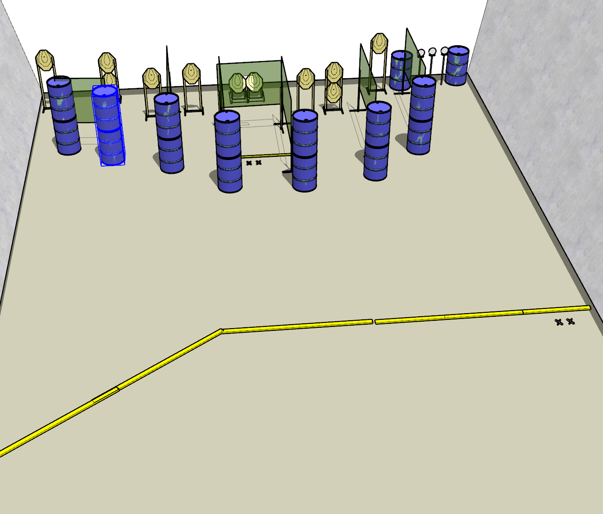

**Written Stage Briefings:**

**Stage 1 –** is a 25-round, 125 point, Comstock Long Course. There are 11 cardboard targets and 3 rubber targets. The best 2 hits per cardboard target will be scored. The rubber targets must fall to score.

**Handgun start position** is anywhere inside the rear shooting area with wrists below belt. The handgun is **loaded** and holstered.

**PCC start position** is standing anywhere inside the shooting area. PCC is **loaded** with buttstock on belt with muzzle pointed downrange.

On the audible start signal, engage targets from within the shooting area.

**Stage 2 –** is a 25-round, 125 point, Comstock Long Course. There are 11 cardboard targets and 3 rubber targets. The best 2 hits per cardboard target will be scored. The rubber targets must fall to score.

**Handgun start position** is standing with both feet on the downrange Xs with wrists above shoulders belt. The handgun is loaded and holstered.

**PCC start position** is standing with both feet on the downrange Xs with strong hand wrist above shoulders. PCC is loaded with safety on and buttstock on belt with muzzle pointed downrange.

On the audible start signal, engage targets from within the shooting area.

**Stage 3 –** is a 22-round, 110 point, Comstock Long Course. There are 11 cardboard targets. The best 2 hits per cardboard target will be scored.

**Handgun start position** is standing with both feet on the right side Xs with wrists below belt. The handgun is **unloaded** and holstered.

**PCC start position** is standing with both feet on the right side Xs. PCC is **unloaded** with safety on and buttstock on belt with muzzle pointed downrange.

On the audible start signal, engage targets from within the shooting area.